
Student Welfare Office
Kotri Kalan, Ashta, Near, Indore Road, Bhopal, Madhya Pradesh 466114

CLUB EVENT REPORT
Date | 15/09/22
Name of the Club | National Service Scheme
Name of the Club Faculty Coordinator/Co-coordinator | Dr. Vinod Bhatt, Dr. Neetu Kalra
Name of the Event | Blood Donation Camp
Date of the Event | 15/12/2022
Venue/Mode | Offline
Numberofstudents participatedintheevent | 180 (approx.)
Numberofregistered students | 350+
Briefabouttheevent (including list of the winners if any)
National Service Scheme, also known as NSS, organized a Blood donation camp in memory of (Late) Smt. Rajeswari Viswanathan(wife of our Hon'ble Chancellor) on 15th December 2022.
Vice ChancellorDr. U. Kamachi Mudali,ProVice Chancellor Dr. Senthil Kumar Arumugam, Registrar Dr. Pradyuman Nayak were present to pay tribute to (Late) Smt. Rajeswari Viswanathan along with our NSS Program Officer Dr. Vinod Bhatt, Dr. Neetu kalra and other faculties.
The Blood donation Camp started with the valuable donation given by Dr. Sriram R and was further continued with blood donation by some faculties and various students present in campus.Apart from some faculties, a total of 160+ Students showed interest of donating their precious blood to save life of people. The camp was a great success as maximum number of registered students turned up and we also provided the facility of onsite registrations for everyone. Energy supplements have been provided to all the donors and were kept under observation for 30 minutes post donation.
The collection of blood units was done by Chirayu Medical College & Hospital, Bhopal. The collected blood unit will save the life of the needy one.
Despite having two venues of the event, the Discipline was properly maintained and camp was smoothly organized by the all NSS Volunteers under the Guidance of Mr. Anubhav (20BOE10076), Mr. Rishabh Kabra (21MSI10017) and Mr. Sahil Chaudhary (21BAI10209).

Photo’s:

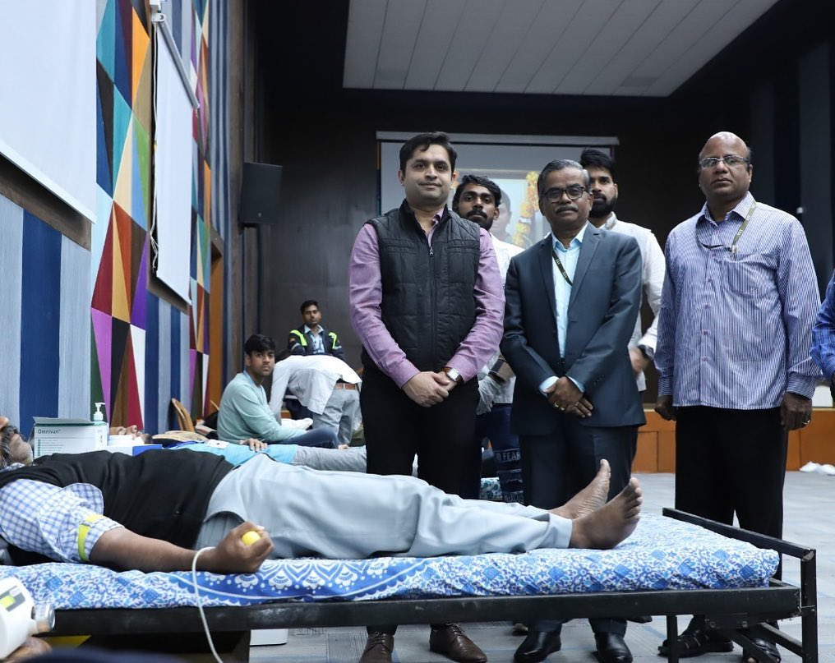

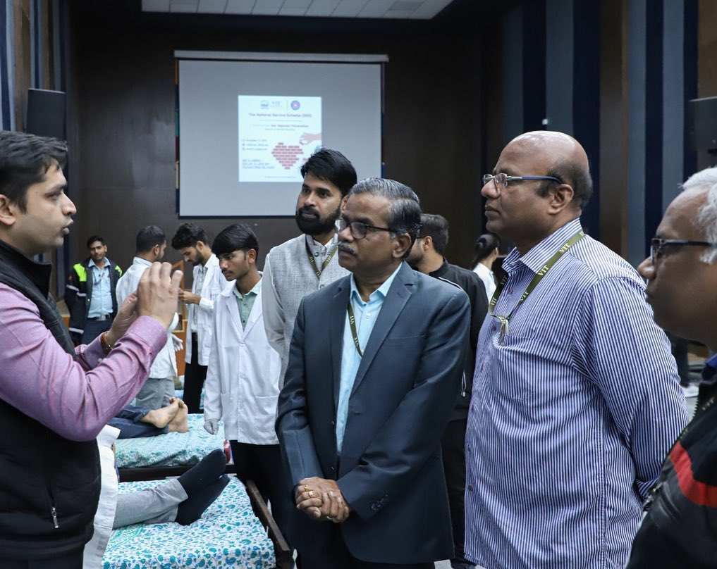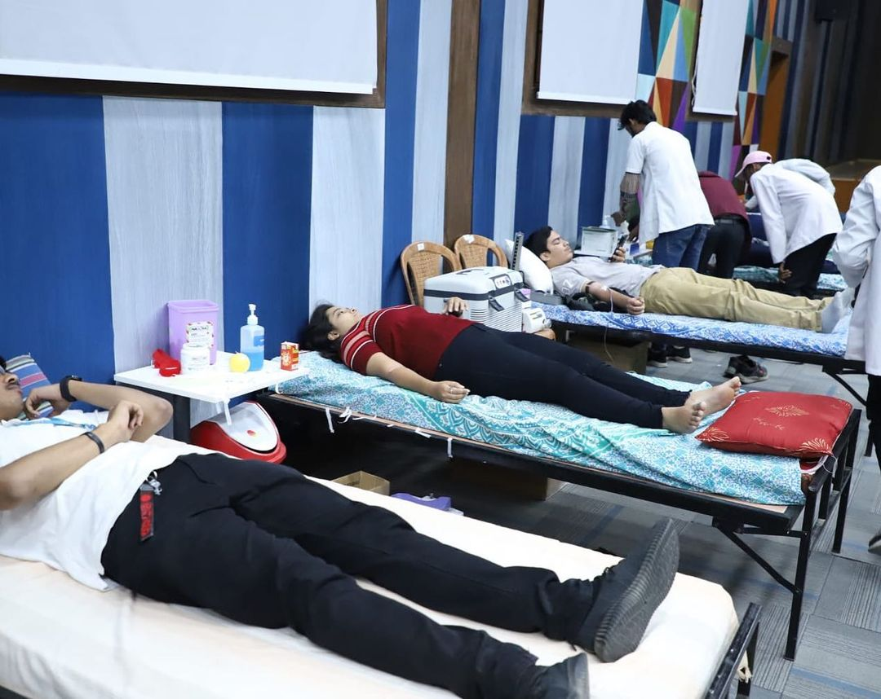

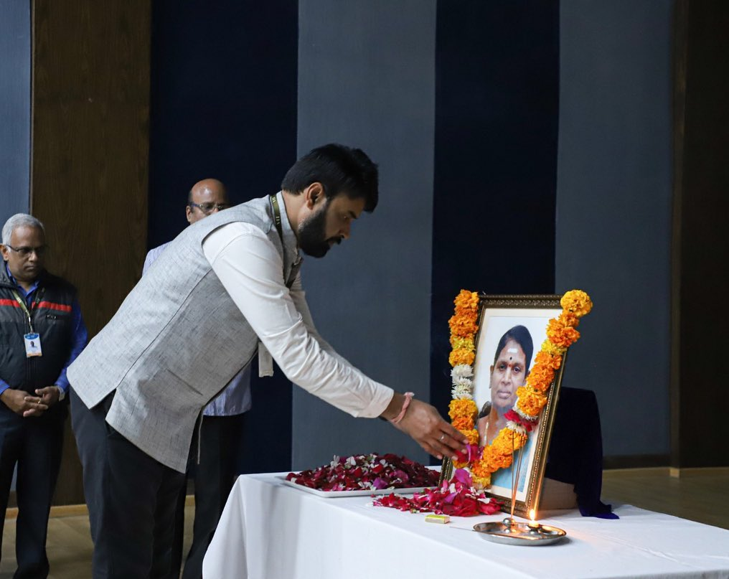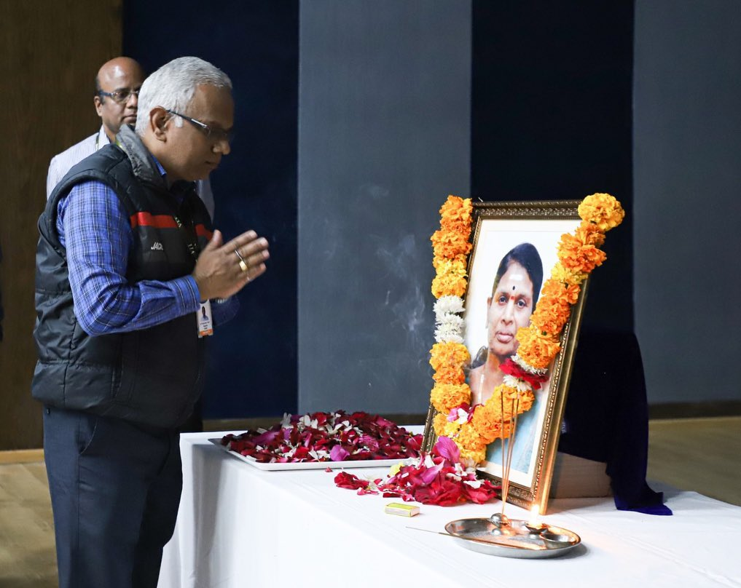

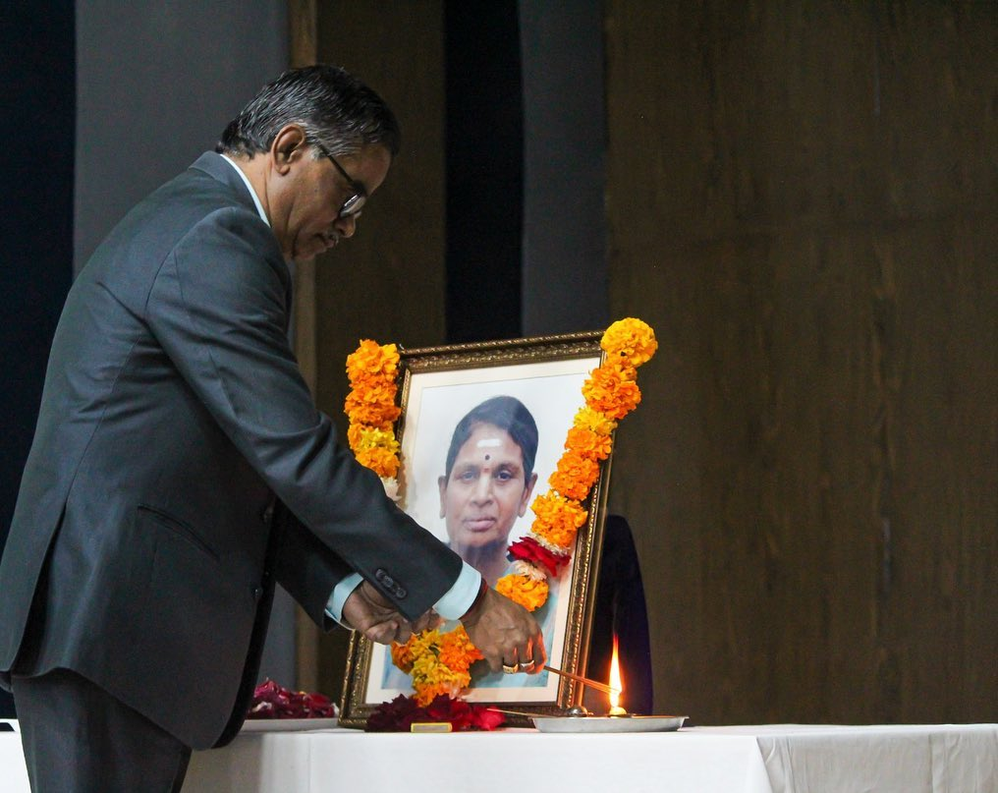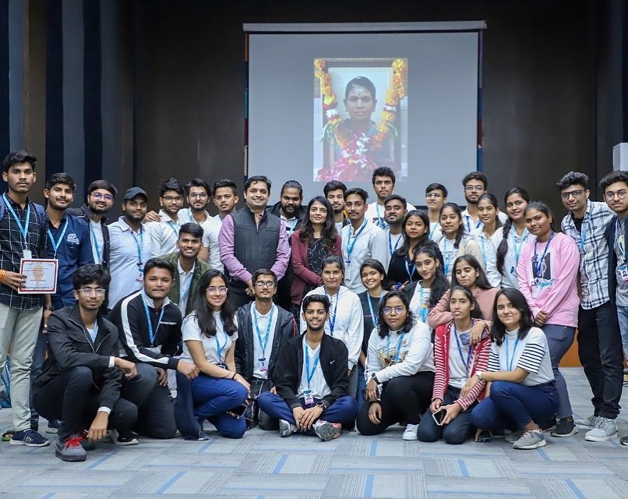

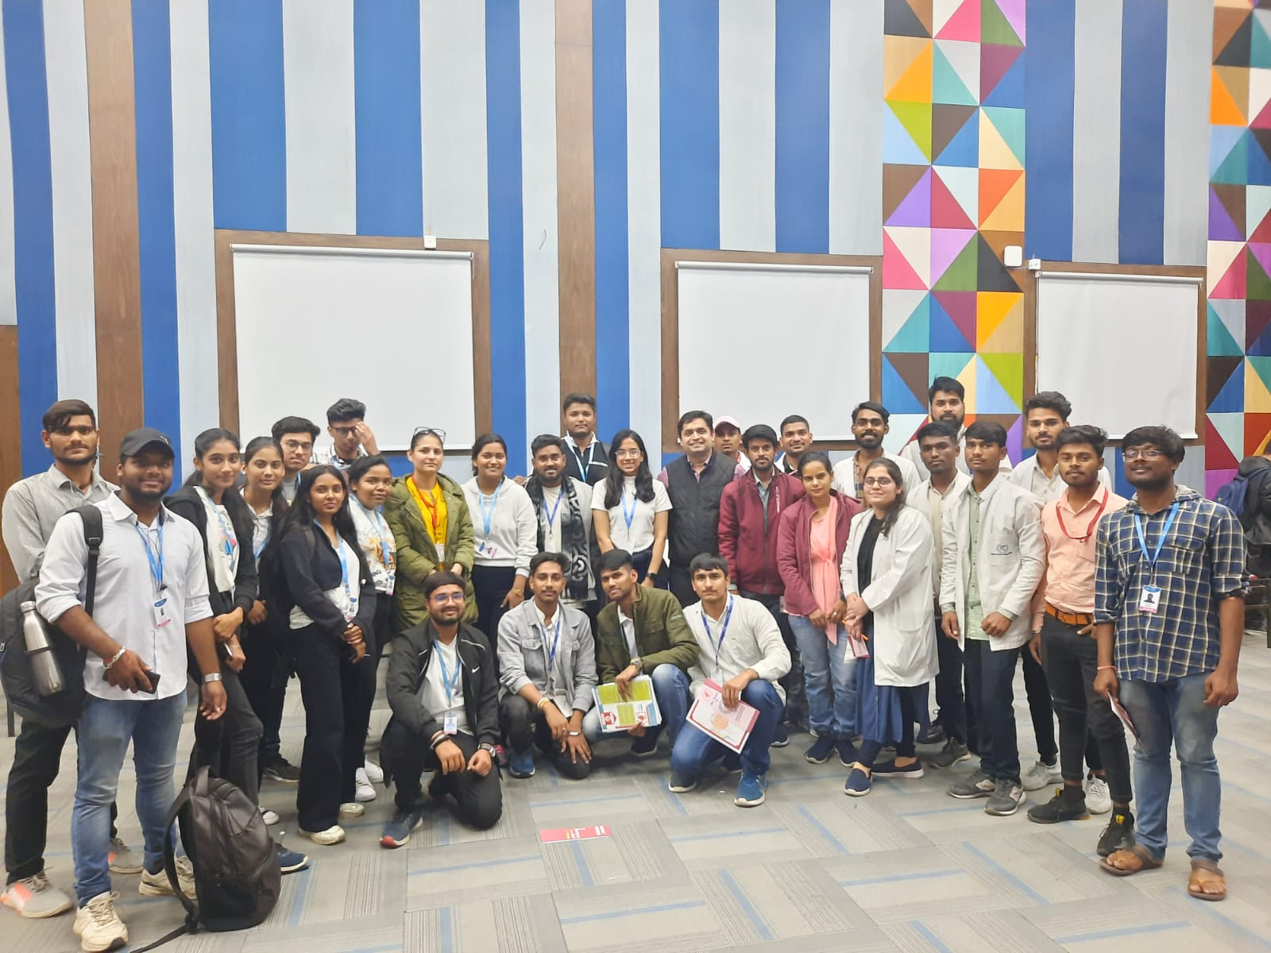

Listof theParticipants:
22BCE10917 | Harshit Parwal
22BOE10119 | Anisha Dhore
20BME10041 | Aditya Singh
22MIP10061 | Vaishnavi Mujmer
20BOE10009 | Bhavik Bhosale
22MIP10027 | Palak Chandani
22BAS10066 | Vaishnavi Joshi
20BOE10039 | Prachi chaturvedi
22BCE10919 | Pritish Agnihotri
22BCE11162 | Ayush Saxena
22BCE10954 | Ajit Dixit
22BSA10029 | Prashant kumar
22BCE10758 | Mehul Udaiwal
22BCY10261 | Divyansh Pradeep Mishra
20BME10025 | Prashant Kumar
22BCY10078 | Rohit Agarwal
22BCY10031 | Mohit keelka
22BOE10034 | Riya Gehlot
20BCE10818 | Aaryan gupta
22BCE10656 | MOHIT JHAJHARIA
20BOE10040 | Vibhorvimal
22MIP10013 | Raj Mishra
22BCY10026 | Aditya Rajeev Patil
20BME10014 | Shubham Mishra
22BAI10219 | Diya shah
20BOE10080 | Subhashree Nayak
22BEY10025 | Antrika Kashyap
22BAC10037 | LakshitGurjar
22BCE11283 | Om Singh
22BAI10283 | MANISH
22BEY10100 | Anshit Kumar
22BAS10076 | Archit Shukla
22BCE11044 | Yatharthnagpal
22BAI10169 | Yashpal yadav
22BHI10175 | Omanshi Kaushal
22BOE10051 | VISHNU PRIYA
20MIP10032 | Rohit singh
22BCE10831 | Virochna Saxena
Registration Number | Name
20BCE10866 | Amit Nain
22BHI10178 | Ekansh Batra
22BCE10179 | Kartikey Agarwal
22BOE10099 | Hanish B Reddy
22BCY10042 | AKSHAY SYAM
22BAI10059 | Nischal Gupta
20BCE10187 | Mudit Sharma
22BME10013 | Ojas Sharma
20BCE10217 | PRANAV SINHA
20BCE10206 | Varsha Dwivedi
22BCY10257 | InsafSadik A S
20BCE10219 | Naman Arora
20BOE10026 | AnshRaizada
20MEI10026 | Yogesh Panchal
20MEI10033 | Sourabh sahu
22BBA10067 | Wudaru Anjana Reddy
22BSA10216 | Ruhani Maheshwari
22BCE11071 | DhaaniBahl
20MEI10071 | Prachi Sharma
22BHI10199 | Kartavya Chaudhary
22BSA10220 | Anuj Raghuwanshi
20BCE10437 | Saee Kiran Kapatkar
22BSA10197 | Aditya Krish
20BCG10017 | AKSHAT SINGH
20BAC10011 | ANIRUDH J BABU
20MEI10056 | Poornima Srivastava
22BCE11493 | Shishantsingh
20BAC10025 | Jigar sharma
22BAI10136 | Mehak Jain
22BCY10044 | Rishika Awasthi
22BMR10003 | Pranav Renduchintala
22BCY10246 | Gaurang Kapil
22BAI10413 | Ritam Goswami
22BMR10011 | Saumya Vishwakarma
22BCY10119 | Ayush Kumar Priyadarshi
22BAS10062 | Sidhartha Banerjee
22BAI10265 | Mayank Singh Rawat
22BHI10075 | Apoorva Singh
20MEI10035 | Bhushan Jadhav
22BCY10020 | PRANJAL KHARE
22BHI10060 | Nupoorsagar
22BCY10167 | Raghvendra Singh
22BSA10092 | Tejit A. Philip
22BSA10139 | Harsh Saxena
22BAI10246 | Ravneetkaur
22MEI10033 | SIYA GARG
22BCE11525 | Aishwary Singh
22MEI10025 | AshinMurugan
22BCE11429 | Harsh Rai
22MIM10004 | Swetha Thampi.M
20MIM10099 | Parvez shaik
22BSA10299 | Abhirami Suresh
9020193920 | Neha R
22BAI10115 | Sreekant Patnaik
20MEI10011 | Akhilesh pokale
20MIM10063 | Sai Siddhartha
22MSI10004 | Kaushik Chengeri
20MEI10051 | DEVANATH E K
22BCE10799 | Anshul Dalvi
22BCG10176 | Anshuman Behera
22BHI10068 | Karan Khatri
22BCE10055 | Mayank raj
20BAS10036 | Shri Hari S
20MIP10044 | Paras Yadav
20BCE10897 | Rudra Kumar Dubey
20MIM10102 | Sameer Jolly
20BCE10069 | Malay Gupta
20MIM10075 | Mayank Narendra Nimje
22BCE10244 | Anshul Deewan
20MIM10033 | Ayush Bhandarkar
22BHI10125 | Aryan Saxena
20BAS10044 | Akriti Mishra
22BCE11043 | Ayush Jha
20BCE10236 | Neelesh Shukla
20BCE10864 | Burhanuddin Chitalwala
22MIP10031 | NITIJ Taneja
20BCE10558 | Karan Gyani
22BCE11551 | TARUNA GUPTA
22BCE10554 | Vrushtinaineshkumarpatel
22BAI10362 | Quratulaaein
22BCE11119 | Aishwarya Singh
22BSA10315 | SATVIK SAXENA
22BCE10419 | Ashish Rawat
20BCY10128 | Ruchita Das
20MIM10118 | AYUSH MANOJ BISOYI
22BAC10037 | LakshitGurjar
22BAI10329 | Adarsh Pandey
22BAI10206 | Anushka Raj
22BCY10014 | SamriddhiKhastagir
22BAI10045 | SHREYANSH JAIN
20BCE11057 | Shlok Mathur
22BCE11553 | Bhanu pratapsingh
22BAI10319 | VidushiLunia
22BAS10058 | Ayush Nigam
22BHI10198 | Sakshi Sharma
22BCE10629 | Rishi kaul
20BCE10643 | Aryan Tiwari
22BAS10103 | K shashankkumar
22BCE11042 | Shashank Kumar
22BEY10028 | KUSHAGRA BANSAL
22BCY10235 | Dev Jitendra Dodia
20BCY10156 | Archit Kumar
20BCY10025 | Mohammad Suboor Hussain Khan
20BCY10201 | Nilankan Pal
20BCY10070 | Aadil Haidar Ali
20BCY10108 | Riddhima Rai
22MEI10031 | Shanushekhargiri
22BCY10197 | Aaryan wadhawan
22BCE10441 | Sparsh Tripathi
22MEI10007 | MohdAfroz
20BCE10490 | ParitoshNimdeo

Budget Summary (if applicable)

Attachposteventpressreleaseoftheevent(If published):

